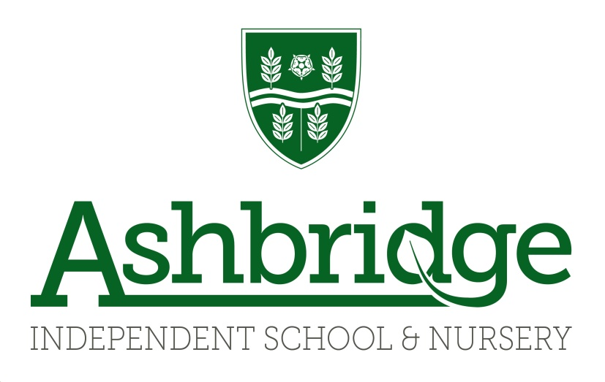
ADMISSIONS POLICY AND PROCEDURES

Approved by: SMT

Approved date: January 2020

To be reviewed by: SMT

Review date: January 2021

Scope: Ashbridge Independent School and Nursery, Ashbridge-on-Ribble Nursery, Ashbridge Nursery at Maxy Farm,
The Fledglings Nursery

Introduction
Ashbridge is a co-educational independent school for children from the age of 3 months to 11 years. We are registered with the Department for Education and are a member of IAPS, the Independent Association of Preparatory Schools. We offer full and part time places in our Nursery department and there is a one form entry from Reception to Year 6.

All the Ashbridge team offer a warm welcome to prospective parents/guardians to visit the school and nursery at any time. The nursery is open annually for 52 weeks and children may start at any time subject to availability of places. Entry into all classes from Reception to Year 6 is usually at the beginning of the academic year. Arrangements can however be made for children to be admitted at different times in consultation with the Headteacher.

We treat all applicants for places in school and nursery in a fair way, regardless of any special educational need or disability. However, whilst we do not discriminate we do consider, prior to offering a place, whether with reasonable adjustments we are able to adequately provide for and fully meet a child’s particular needs. At no time will children be discriminated against for any other reasons, including discrimination based on age, gender, race, religion or belief, sex or sexual orientation providing we can meet the child’s needs.

We ask parents/guardians to speak directly with a member of the Senior Management Team or Nurseyrv Management Tea and inform us of any special needs or circumstances which may affect the child’s ability to access the curriculum and our Special Educational Needs policy includes further details to support this process.

Where we find and subsequently decide we are unable, within our established provision and with making reasonable adjustments, to adequately provide for a child’s needs, we do reserve the right to not offer a place in the child’s best interests.

Registration / Entry to the Nursery
Parents/guardians requesting a place in Nursery may do so following consideration of the regulations and enrolment details and a visit to the Nursery. Applications will be considered subject to availability.

To secure a place we require a fully completed enrolment form, a copy of a child’s birth certificate plus a deposit of £100. Four weeks’ fees are due before the child starts nursery. For further details please see Terms and Conditions.

Children who attend any Ashbridge Nursery receive priority for places at Ashbridge School over external applicants.

Registration / Entry to the School
Parents/guardians requesting a school place may do so following consideration of the regulations, terms and enrolment conditions and a visit to the school.

Procedures at this stage may also include:
- A meeting with the Headteacher
- Time spent in school in the appropriate year group for children requesting entry to Year 1-6 during which an academic assessment maybe administered by the class and Headteacher.

Enrolment forms for admittance to the Reception Class in the following year must be received for consideration no later than the previous 14th November. Children entering Reception Class may do so in the September following their fourth birthday.

When demand for places exceeds availability, priority is given in the following order:
- Siblings of children who already attend
- Children of current employees
- Children who are attending the nursery
- External Applications

Applications will be ordered in each category by the date the enrolment for and £100 was received.

Applications are then considered for places and place offers are sent out by the Headteacher in writing by 30th November at the latest, at which point a deposit of a term’s fees is due. Parents/guardians will be asked to pay a proportion of the term’s deposit with two weeks of receipt of the offer letter, with the remaining paid either in instalments over the following months for current nursery children, or in a second lump sum for children who are not already enrolled at an Ashbridge nursery.

In the event of an application being made after the 14th November for Reception class, or for children starting any year group at a point after 1st September, the admissions process begins immediately. The Senior Management Team will decide on the payment date of the term’s deposit on a case by case basis depending on a number of factors including:
- The time of the year
- The lead time between an application being made and a child requiring a place
- Whether the place is for one child or multiple children

In all cases, payment of a term’s deposit is required to be paid before the child starts school. Parents may also be required to sign a contract that they agree to pay at minimum of a full year’s fees, even if the child leaves during their first year or does not take up a place in school.

On acceptance of the place, parents/guardians agree to be bound by the terms and conditions of the school.

Waiting list
Applicants who are not offered a place may then be placed on a waiting list. When a place becomes available the Management Team will contact prospective parents to ascertain if they still wish to be considered. If they do the admissions process can begin.

Please note that all documentation relating to applications and admissions will be treated in confidence and in accordance with the Data Protection Act and GDPR.

